University of Waterloo

Department of Mechanical and Mechatronics Engineering

MTE 111

Lab 3: Fracture and Failure

Prof. Yimin Wu

Group #23: Ian Jinzo Macpherson Takeda, Joe Chen, Pedro Brossel, Randy Jayasinghe

July 14th, 2023

**SUMMARY**

During this lab, two experiments were performed. The first experiment was conducted to study the ductile/brittle transition in AISI-1045 steel and 6061-T6 annealed aluminum alloy Charpy specimens under different temperatures using the Charpy test. The measurements were conducted in an impact testing machine, where materials were placed on a support, a pendulum hammer was swung and the material was broken in half upon impact with the hammer.

After the experiment, it was concluded that steel has a ductile-to-brittle transition temperature of roughly 75 °C, while aluminum does not have one. The reasons for this phenomenon were discussed, and possible sources of error were explained based on graphs and tables.

The second experiment was conducted to study the fast fracture phenomenon and establish the critical fracture toughness of polycarbonate. After the experiment, it was concluded that the longer the crack length, the higher the critical fracture toughness. The experimental values and the published values were compared and possible sources of error were explained.

**INTRODUCTION**

Of the two experiments performed, the first was an impact fracture test, done to obtain the impact energies absorbed by the different materials. These values were then plotted on a graph against the temperature each sample was at, which was used to determine the upper and lower shelf energies for the samples of aluminum and steel. These graphs were subsequently used to identify the ductile-to-brittle transition temperatures for the two materials. Further in the report, reasoning as to why certain metals do not exhibit low embrittlement was given and elaborated on. Additionally, details on processes used to make ductile metals at low temperatures were described and evaluated, and the possible sources of error and inaccuracy in the experiment were outlined.

The second experiment was a fracture toughness test, in which three similar polycarbonate strips were put into a tensile tester and a stress was applied at an approximately constant rate until fracture. The force experienced at fracture was recorded and later converted to stress for each sample. These values were then used in equations provided to calculate an estimate of each sample’s critical fracture toughness. The calculated values were then compared to each other, as well as the corresponding values published online. The discrepancies between them were detailed, and possible reasons for the discrepancies were analysed as well. In addition, variables that affect the design of a component were discussed and evaluated as well.

For both experiments, this report also details and evaluates the safety measures taken into account, as well as describes the engineering tools that were used to perform the experiments and any measurements or data collection required for them.

**PART A: IMPACT FRACTURE TEST**

**EXPERIMENTAL PROCEDURE:**

The purpose of this experiment was to perform the Charpy test on pieces of aluminum and steel heated and cooled to different temperatures, in order to analyze the impact energies absorbed by each sample and use the data for further discussion. In order to perform the Charpy test, the below steps were carried out:

1. A sample of aluminum was removed from its temperature-controlled medium and loaded into the impact testing machine.
2. The impact testing machine was activated and the sample was fractured. The fractured pieces of the sample were then removed from the testing machine and put aside for inspection.
3. The energy absorbed by the sample at fracture was logged from the machine’s display.
4. A sample of steel (kept at the same temperature of the aluminum) was loaded into the impact testing machine.
5. Step 2 was repeated for the sample of steel.
6. Steps 1-4 were repeated for alternating samples of aluminum and steel kept at different temperatures

Table 1 below shows the temperatures each sample was kept at and the medium in which the sample was kept to keep that temperature constant.

| **Temperature (℃)** | **Medium** |
| --- | --- |
| 120 | Furnace |
| 60 | Oven |
| 25 | Room temperature |
| 0 | Ice bath |
| -60 | Dry ice |
| -196 | Liquid nitrogen |

Table 1: Temperatures and media

After the raw data had been recorded, a spreadsheet was used to process this data and construct related and useful graphs and tables. These graphs were later used to determine the ductile-to-brittle transition temperature for both steel and aluminum.

**RESULTS:**

Upper and Lower Shelf Energies for Aluminum and Steel:

The graphs for absorbed energy against temperature for steel and aluminum can be found below.

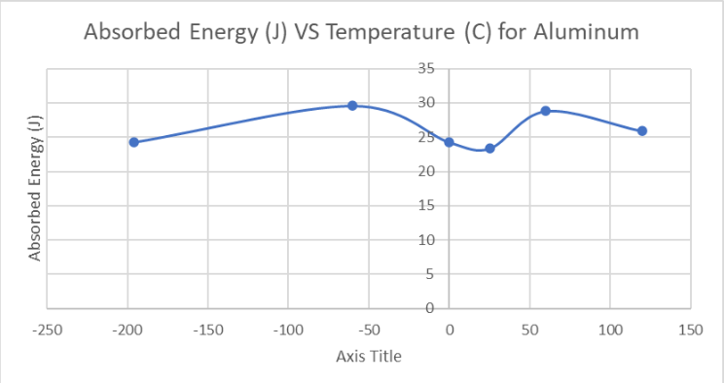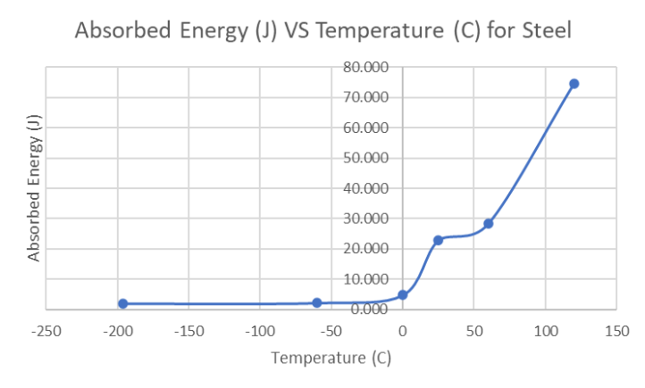

Analyzing the graph for steel, the “lower shelf” energy is found to be around 2.11 J whereas the “upper shelf” energy is 74.59 J, since it is the highest available data point and where the metal is the most ductile.

Ductile-To-Brittle Transition Temperatures:

The transition temperature for steel can be estimated to be the temperature at the midpoint between its upper and lower shelves. Thus, the ductile-to-brittle transition temperature for steel is found by calculating the average absorbed energy between the upper and lower shelves (38.35 J) and finding the corresponding temperature which is 75℃.

Aluminum, on the other hand, does not have obvious lower and upper shelves. With no significant changes in absorbed energy with the variation of temperatures, aluminum is found to not have a transition temperature.

**DISCUSSION:**

Comparison of Transition Temperature:

Steel has a transition temperature of roughly 75 °C as mentioned above. At colder temperatures (nearing the lower shelf energy), steel behaves in a brittle manner, absorbing low amounts of energy before fracturing. At temperatures above the transition temperature (nearing the upper shelf energy), the material is able to absorb more energy before fracture, which indicates a transition to a more ductile behaviour by the sample.

Aluminum is inherently ductile due to its FCC structure, meaning it does not have a ductile-to-brittle transition temperature, and the absorbed temperature is fairly high, remaining relatively constant through the experiment.

Lack of Low-Temperature Embrittlement In Metals

Low-temperature embrittlement is caused by the immobility of dislocations. Some materials do not demonstrate low-temperature embrittlement below a certain temperature due to their microstructure, as certain crystal structures allow more dislocation motion. The stress required to move dislocations is not strongly temperature dependent in FCC metals. However, BCC structures need to be thermally activated in order to have mobile dislocations, because the movement of dislocations happens only as a line of atoms jumps from one potential energy valley to another. Since the planes in BCC are not as closed-packed and any slip means a corner atom being moved to the center of a unit cell, there would be propagation of the dislocation motion caused by the high activation energy needed to move an entire row of atoms from corner to center. Compared to FCC metals, which move corner atoms to the center of the face in a unit cell, BCC dislocations have a much higher energy requirement in order to stay ductile. Otherwise, they would fail to support the stress applied by the formation of cracks [1].

The Process Of Making Ductile Steel At Low Temperatures:

One way to make steel less brittle at low temperatures is to reduce the impurities, such as carbon, present in it. This phenomenon occurs due to steel’s tendency to form martensite (a structure of steel containing high carbon content) that is very hard and brittle [2]. In low temperatures, this property is amplified, since decreasing carbon impurities in metal will reduce its brittleness. Another method is to introduce more nickel or manganese content into steel. Nickel prevents the formation of brittle phases in steel microstructures [3], while manganese promotes the formation of fine-grained structures that increase the ductility of steel at low temperatures [4].

Accuracy and Possible Sources of Error

While performing the Charpy test, there are a number of things that could have caused data inaccuracies. For instance, the ASTM standard for the Charpy impact test requires that the delay time in transferring the specimen and performing the test must be less than 5 seconds. The temperature at the root of the notch begins to change as soon as the sample is removed from the heating or cooling medium. This would have impacted the reading as the time it took for the transfer was longer than 5 seconds. The pendulum hammer may not have been calibrated before conducting the test [A]. This could have impacted the digital readout values of the energy absorbed by each specimen, compromising their accuracy. The sample could have been misaligned when testing each specimen, adjusting the specimen to be secured symmetrically and perpendicular to the hammer would be a difficult task to do with minimal failure. A misalignment and failure to properly secure the specimen would result in an uneven distribution of stress applied to the material, changing the amount of energy the specimen can absorb [7]. These errors can affect the accuracy of the Charpy test since it would change the amount of energy both recorded.

Safety of Experiment:

This experiment was conducted in a safe manner, however there were a few safety hazards. When dealing with extreme temperatures (too high or too low) the materials must be handled with care and precaution. After the test, the broken samples of the material were placed beside students who were not using personal protective equipment. This could have led to a student accidentally touching a very hot or cold specimen.

Engineering Tools:

This experiment was conducted using a Tinius-Olsen Charpy impact tester, to measure the energy absorbed from the pendulum hammer after making contact with the test specimen. Other tools such as a furnace, oven, ice bath, dry ice and liquid nitrogen were used to change and maintain the temperature of the specimens. Tongs and gloves were used to help insert the specimen into the Charpy impact tester to avoid potential injury to the person conducting the experiment. A thermometer was used to read the temperature of the material before and after the testing process.

**PART B: FRACTURE TOUGHNESS TEST**

**EXPERIMENTAL PROCEDURE:**

This experiment was conducted to study the fracture behaviour of polycarbonate and to find its critical fracture toughness. In order to do so, a tensile test was performed on different polycarbonate samples with varying crack lengths (5mm, 10mm, and 15mm). The steps below were performed for this experiment.

1. The thickness, length, width and actual crack length of the polycarbonate sample were measured.
2. Each sample was placed in a tensile tester with its crack at the centre and firmly held together by the grippers.
3. A progressively increasing load was applied on each specimen by rotating the hand wheel until fracture.
4. The last tensile force shown (right before fracture) was recorded.
5. Steps 1-4 were repeated for the remaining samples

During the experiment, a video was taken to record the tensile forces applied to the specimen until the moment before fracture. A spreadsheet was then used to process the collected data and create useful tables and graphs, which would later be used to calculate the critical fracture toughness of each sample.

**RESULTS:**

Figs. 3-5 below show the calculations done to estimate the critical fracture toughness of each of the three polycarbonate strips, which will be differentiated by the crack lengths in each of them. In all three cases, as the crack can be seen on the surface of the material, its width will be used as the variable ‘a’. 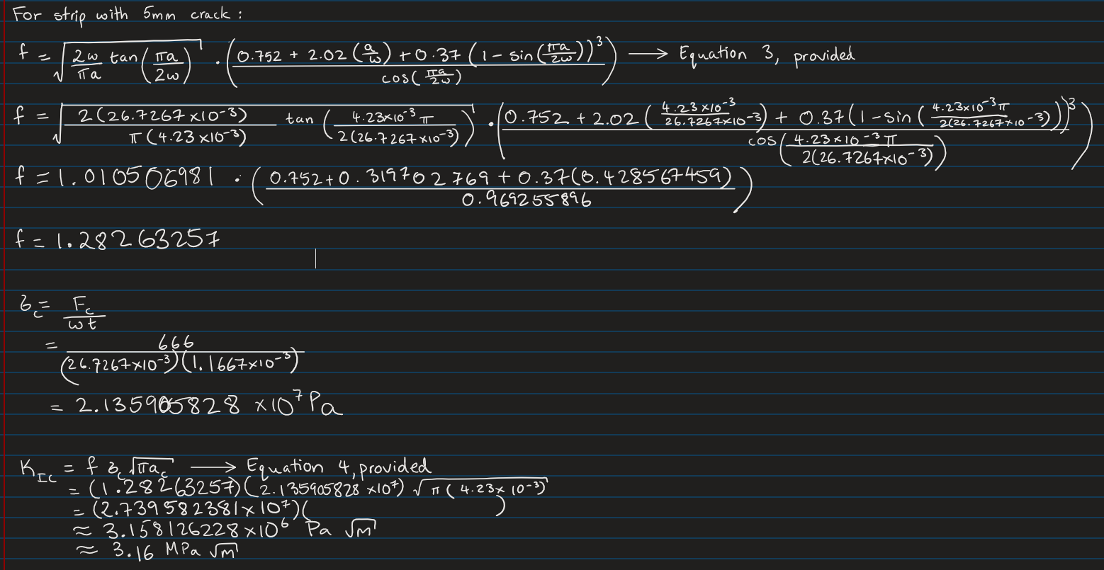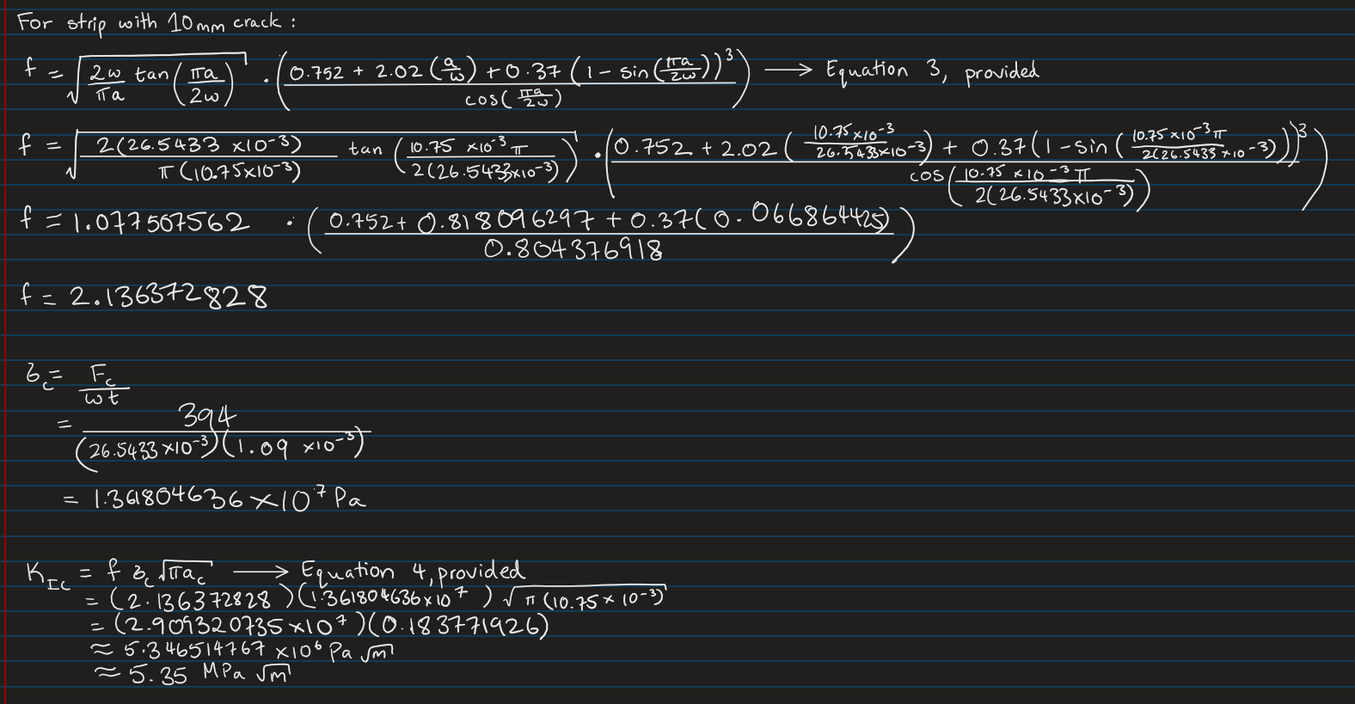





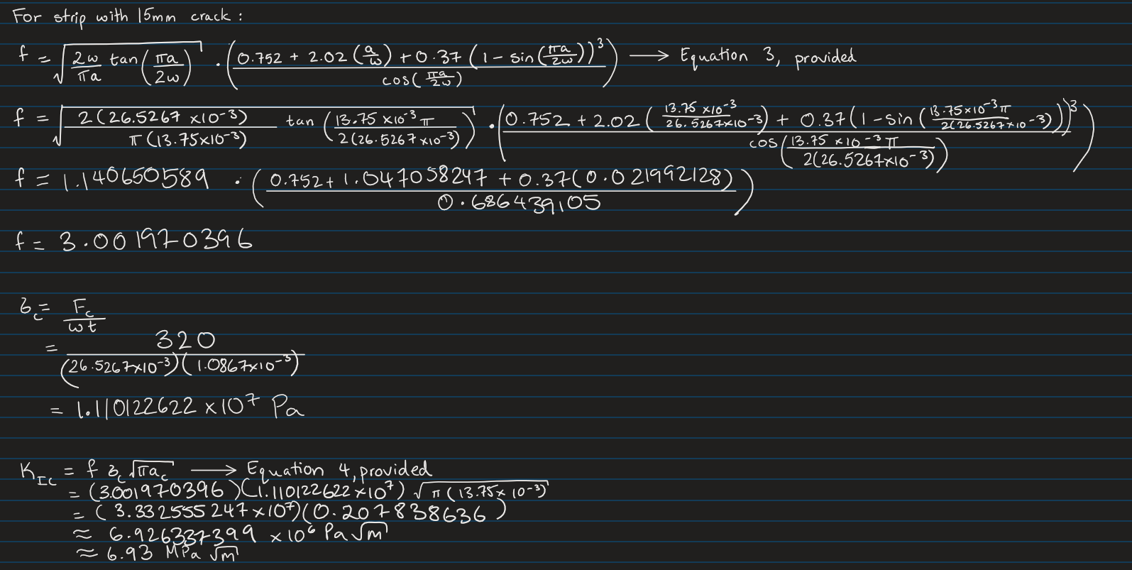



As mentioned in the Experimental Procedure, the width and thickness of each sample was measured from different places and an average was taken. The length of the crack in each sample was measured as well. These values were used in equations (3) and (4) provided to calculate the stress applied to the sample at fracture as well as its critical fracture toughness.

As shown in Table 2, the calculated critical fracture toughness of each sample increased with the increase in crack length.

| **Length of Crack (mm)** | **Critical Fracture Toughness (MPa m1/2)** |
| --- | --- |
| 4.23 | 3.16 |
| 10.75 | 5.35 |
| 13.75 | 6.93 |

Table 2: Length of crack (mm) and corresponding critical fracture toughness MPa m1/2 for each sample

**DISCUSSION:**

Comparison of Fracture Toughness Values Between Samples:

The three calculated fracture toughness values (seen in Table 1) are relatively low, indicating that polycarbonate is a relatively brittle material [5]. Further, as is evident from Table 1, the three values for critical fracture toughness are not the same. This is contrary to the expectation, since the critical fracture toughness is a material property, and the three tested samples were made of the same material, the calculated values should be the same (within a tolerance range accounting for experimental errors). However, the values were found to instead increase with increasing crack length by a considerable margin.

This variation from the expectation is mainly due to the possibility of inherent material defects between each sample. Though they are made of the same material from a macrostructural perspective, there are bound to be microstructural defects or features that vary between each sample. This means that though each sample was subjected to approximately the same strain rate, the samples would react differently under stress based on the microstructure and composition of each individual sample. Further, the sample thickness would have affected the fracture toughness as well. The general expected trend is that fracture toughness would increase with decreasing thickness [6]. The samples tested are seen to follow this trend, as the thinnest of the three samples (1.087 mm thick) had the largest calculated fracture toughness (6.93 MPa m1/2), while the thickest sample (1.16 mm thick) had the lowest (3.16 MPa m1/2).

In addition, environmental factors would have played a part in introducing error into the measured values. Though the temperature of each sample was approximately the same, there would have been minor differences due to handling that could have caused the samples to have slightly differing internal temperatures. This, along with experimental errors in measurement, would have contributed to the differences in critical fracture toughness. However, the magnitude of this contribution would be much smaller than that of the inherent material defects and sample thickness mentioned earlier.

Comparison of Calculated Values for Fracture Toughness with Published Values:

The average of the experimentally determined fracture toughness values for polycarbonate was approximately 5.14 MPa m1/2 . This value is greater than the published value of polycarbonate, which is approximately 1.9 MPa m1/2[8]. Other materials such as age-wrought aluminum or low carbon steel have significantly higher fracture toughness values (27.5 MPa m1/2 [9] and 33MPa m1/2 [10] respectively). It is much closer to materials such as alumina (Al2O3), which has a fracture toughness of 3.3 MPa m1/2 [11]. Other ceramics have lower fracture toughness values than age-wrought aluminum and low carbon steel, such as Si3N4-SiC, which has a fracture toughness of 16.8 MPa m1/2 [12].

Variables Affecting Component Design:

The three critical variables that affect the design of a component are the minimum flaw size ‘a’ that can be detected, the nominal stress ‘σ’ and the critical fracture toughness of the material KIC. The value of ‘a’ is given by the resolution of the detection equipment. The nominal stress is obtained by the mechanical design. A material must be selected with sufficient fracture toughness so that the design structure will not fail by fast fracture due to a crack which cannot be detected during a routine inspection procedure.

Safety of Experiment:

While using a tensile tester, students were standing very close to the machine, which could have put them at risk due to small particles of the specimen being shot out during a fracture. This is further reinforced by the lack of PPE available during the experiment, such as protective glasses and sleeves.

Engineering Tools:

For this experiment, a tensile tester was used to collect data of the force applied to samples of polycarbonate. The samples of polycarbonate had their dimensions recorded using a caliper before testing.

**CONCLUSION:**

In Part A, it was found that 6061-T6 aluminum alloy had a fairly constant energy absorption with varying temperature. This happens due to the inherent FCC structure whose ductility is not temperature dependent. AISI-1045 steel, on the other hand, had varying absorption energy when temperature was changed. At lower temperatures, steel remained at a “lower shelf” of roughly 2 J of absorbed energy. As the temperature increased, steel eventually settled at a “higher shelf” of around 74.6 J. It was found that the brittle-to-ductile transition of steel occurred at 75 °C. This happens because steel’s BCC microstructure needs higher activation energy to have mobile dislocations than aluminum.

In Part B, it was found that the critical fracture toughness values for the tested polycarbonate strips increased with an increase in their flaw sizes, ranging from 3.16 MPa m1/2 to 6.93 MPa m1/2. This was contrary to the expectation, as critical fracture toughness is a material property and the strips were made of the same material. The possible reasons for the differences between the values were detailed, and comparisons between the calculated and published values were made as well. Finally, the three variables that affect the design of a component were listed, and their impacts on component design were explained in detail.

**REFERENCES**

[1] “condensed matter - Why don’t FCC metals have a brittle-to-ductile temperature transition?,” *Physics Stack Exchange*. https://physics.stackexchange.com/questions/74983/why-dont-fcc-metals-have-a-brittle-to-ductile-temperature-transition

[2] B. Capudean, “Carbon metal content, Classification of Steel and Alloy Steels,” *Thefabricator.com*, Aug. 28, 2003. https://www.thefabricator.com/thewelder/article/metalsmaterials/carbon-metal-content-classification-of-steel-and-alloy-steels#:~:text=Generally%2C%20carbon%20is%20the%20most

[3] “Most Common Alloying Elements in Steel,” *Diehl Tool Steel, Inc.* https://www.diehlsteel.com/technical-information/effects-of-common-alloying-elements-in-steel/#:~:text=Nickel%20(NI) (accessed Jul. 16, 2023).

[4] “The Influence of Manganese in Steel | Industrial Heating,” *www.industrialheating.com*. https://www.industrialheating.com/articles/89322-the-influence-of-manganese-in-steel#:~:text=Manganese%20contributes%20to%20strength%20and

[5] “Fracture Toughness - an overview | ScienceDirect Topics,” *Sciencedirect.com*, 2019. https://www.sciencedirect.com/topics/engineering/fracture-toughness

[6] H. Zhang, H. Zhang, X. Zhao, Y. Wang, and N. Li, “Study of Thickness Effect on Fracture Toughness of High Grade Pipeline Steel,” *MATEC Web of Conferences*, vol. 67, no. 67, p. 03016, 2016, doi: https://doi.org/10.1051/matecconf/20166703016.

[7] M. Testing Team , “How do you troubleshoot and resolve common problems or errors in the Charpy Impact Test?,” Troubleshooting Common Problems in Charpy Impact Test, https://www.linkedin.com/advice/0/how-do-you-troubleshoot-resolve-common-problems-1e#:~:text=One%20of%20the%20possible%20sources,indicator%20reads%20the%20correct%20value. (accessed Jul. 17, 2023).

[8] Author links open overlay panelHiro Uete, AbstractA number of polycarbonate (PC) specimens, C. Gurney, R. W. Boyle, and P. L. Key, “Determination of the fracture toughness of polycarbonate using an energy approach,” International Journal of Mechanical Sciences, https://www.sciencedirect.com/science/article/pii/0020740383900024 (accessed Jul. 17, 2023).

[9] Author links open overlay panelM.O. Lai ∗, M. O. ∗Lai , AbstractThe fracture toughness of high strength aluminium alloy 7075-T6 in the as-cast condition was studied using standard compact tension specimens with thicknesses ranging from 4 to 25 mm with a 3 mm incremental interval. ASTM Standard E 399-74 for pla, and W. G. Ferguson , “Fracture toughness of aluminium alloy 7075-T6 in the as-cast condition,” Materials Science and Engineering, https://www.sciencedirect.com/science/article/pii/0025541685904264#:~:text=The%20plane%20strain%20fracture%20toughness%20is%2027.5%20MPa%20m%201%202%20. (accessed Jul. 17, 2023).

[10] “The Online Materials Information Resource,” MatWeb, https://www.matweb.com/search/DataSheet.aspx?MatGUID=034970339dd14349a8297d2c83134649&ckck=1 (accessed Jul. 17, 2023).

[11] F. X. Scientific et al., “Properties: Alumina - aluminium oxide - al2o3 - a refractory ceramic oxide,” AZoM.com, https://www.azom.com/properties.aspx?ArticleID=52 (accessed Jul. 17, 2023).

[12] Author links open overlay panelC.C. Ye a b c et al., “Fracture toughness of SI3N4 ceramic composites: Effect of texture,” Journal of the European Ceramic Society, https://www.sciencedirect.com/science/article/pii/S0955221921004180#:~:text=Multilayer%20Si3N4,4411%20J%2Fm2). (accessed Jul. 17, 2023).